# Documentation of

## **iDT-NaPaMeGs**

### Inverse design tool for nanoparticle meta-grid based photonic devices

### using computational electromagnetics and deep l

# Data Generation using MATLAB scripting

To develop the forward and inverse design models, the primary aim of this project, we would need a lot of data. This data, is however, not available anywhere on the internet or elsewhere.

So, we are generating the dataset on our own using MATLAB scripting. The main formula, which draws a relationship between the geometrical feature of a nanoparticle meta-grid and and its optical response in a particular spectrum is determined by Dr. Debabrata Sikdar himself as a part of his post-doctoral research.

His research work is being implemented in the form of a MATLAB script which is run in Param Ishan (supercomputer of IIT Guwahati) in parallel computing mode. Before diving into how to generate massive data using MATLAB parallel computing on Param Ishan, let us look into the specifications of the data to be generated.

## Data Specification

The entire project is sub divided into three parts. First part is for semiconductor LEDs, second for Organic LEDs and the third for Solar Cells. For each part, massive dataset will be generated for given specifications of the LED or solar cell and the nanoparticle meta-grid structure.

Using each dataset, an Inverse Design model will be trained to predict the required nanophotonic structure for desired optical response.

Once a model is built for the Inverse designing of Semiconductor LEDs, the process for Organic LEDs and Solar cells will use the same architecture. In other words, the rest of the work post Semiconductor LEDs will be repetitive in nature.

For semiconductor LED, the dataset is generated by varying the several physical parameters of the nanoparticle meta-grid, position of the meta-grid layer above the LED semiconductor and the Transmittance of the same over the spectral range.

The various combination is as followed.

|  |  |  |
| --- | --- | --- |
| **Parameter** | **Range** | **Step** |
| Height of NP layer above LED semiconductor (h) | 0 to 1000 nm | 1 nm |
| Radius of each NP material (r) | 5 to 150 nm | 1 nm |
| Gap between two NP materials (g) | 2 to 200 nm | 1 nm |
| Encapsulant refractive index (n1) | 1 or 1.58 | -- |
| Semiconductor refractive index (n2) | 2.5 to 4.3 | 0.3 |
| Shape of NP array | Spherical Hexagonal or Cubic Square | -- |
| Angle of incidence | 0° to sin-1(n1/n2) | 1° |
| Wavelength | 400 to 2500 nm | 1 nm |

With these combinations, the Transmittance and Reflectance values for s and p-polarisation is determined by MATLAB scripting.

## MATLAB scripting

Followed next is the step-by-step guide to generate massive dataset using MATLAB scripting.

It is to be noted here that although the MATLAB scripts are run in Param Ishan, it is submitted through MATLAB GUI on local PC. Simple Linux Utility for Resource Management (SLURM) then takes the job and assigns it to specified number of cores across several nodes.

Each node on Param Ishan has 24 cores (or workers). While submitting a MATLAB job (process explained below) we can only specify the number of cores we intend to use for the particular script. It is then job of SLURM to balance the load between available nodes. It is advisable to use cores in multiple of 12, to ensure proper load balancing.

Before using MATLAB for parallel computing, install “Parallel Computing Toolbox” and “Parallel Computing Toolbox plugin for MATLAB Parallel Server with Slurm” from MATLAB add-ons explorer. Refer to the manual floated by CC department for configuration of MATLAB parallel computing profile on Param Ishan.

After successful configuration, comes the part of running the script.

The entire code has been split into 3 parts. The first part is named as “Data_generation_code_1.m”, the second as “get_fn_T_avg_theta.m” and the third as “submit_and_store.m”.

The geometrical and other specifications of the nanoparticle meta-grid is set in the first script. From the first script, the “get_fn_T_avg_theta.m” script is called, which is basically a function with nested loops on gap and theta values.

Basically, to run a MATLAB loop in parallel cluster, one of the many ways is to use the **parfor** (parallel for) function. Inside a parfor loop, one can use at most one nested for loop.

It is very important to note here that in a script only one parfor loop can be used, and the recommended practice is to make the outermost loop as the parfor loop. This ensures optimal utilisation of the parallel computing feature.

This modification is generally termed as parallelisation of general MATLAB code for use in parallel cluster.

As mentioned in the combination table, our code needs 4 nested loops in total, each for height, radius, gap and theta respectively. The last two loops, i.e., gap and theta are kept inside the “get_fn_T_avg_theta.m” script. When this function is called from inside the for loop for radius, which itself is inside the parfor loop for height, it works perfectly without any issue.

The third script, “submit_and_store.m” is used to specify the number of cores required, actually submit the job to Param Ishan and to also specify the location to store the output files generated.

### Script modification for each run: Main script

Given the number of combinations we want to run, it is not possible to generate data for all the combinations in one go. Instead, we will have to split the entire job into numerous sub-jobs on the basis of geometrical combinations.

Even for the data generated, as we are using parallel cluster for computing, separate files should be made for storing. The script is configured for the same.

In the figures 1 thorugh 5 attached below, the entire “Data_generation_code.m” script can be viewed.

The values till line number 15 (Fig 1) need not be changed, unless there is any decision to generate data for some other combination.

In line 19, the value of ‘n2’ must remain fixed for 4 combinations (2*2) of ‘isHex’ and ‘n1’. This should repeat for all 7 values of ‘n2’. The scheme for storing the data generated has been explained later in this documentation.

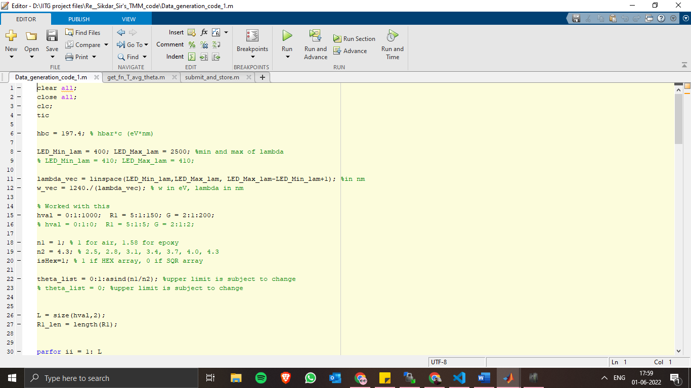The ‘theta_list’ also should remain unchanged.

Figure 1: Data Generation (1/5)

The next modification is required in the permittivity values. The script is already loaded with the permittivity values of all 5 NP material. The only modification required is uncommenting the permittivity values for required material and commenting the rest.

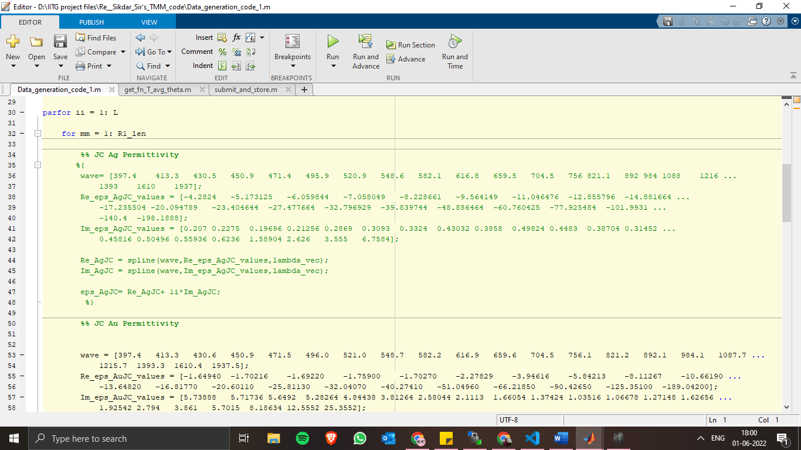

Figure 2: Data Generation (2/5)

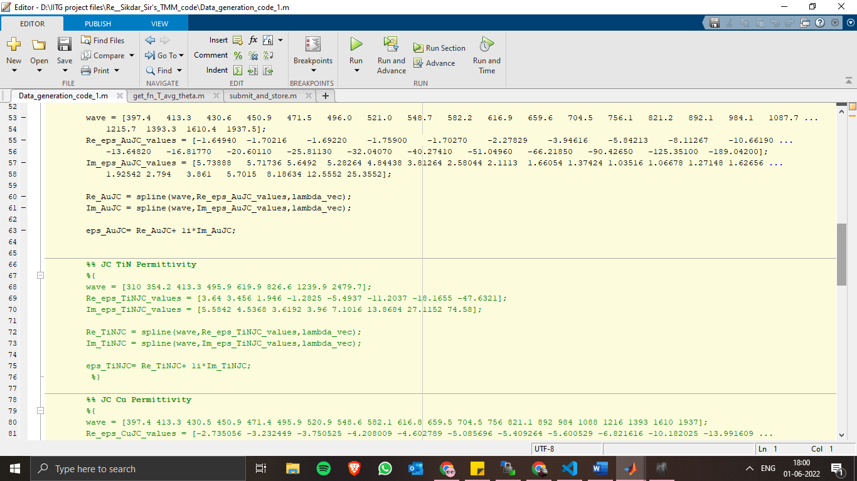

Figure 3: Data Generation (3/5)

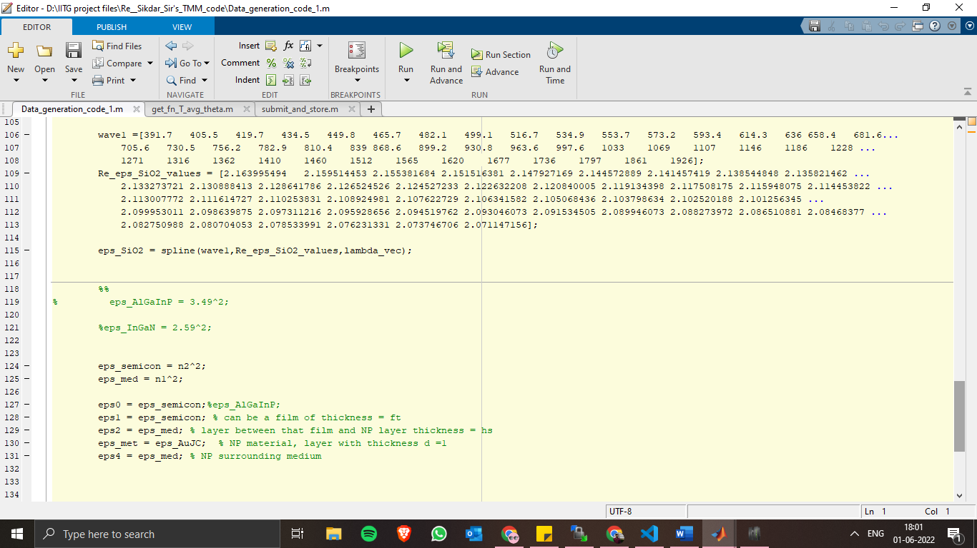

Figure 4: Data Generation (4/5)

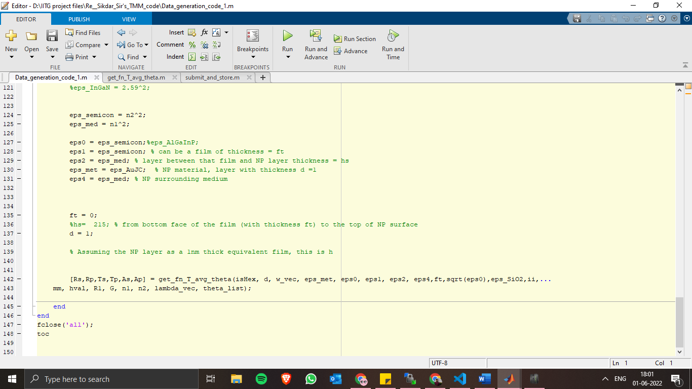

Figure 5: Data Generation (5/5)

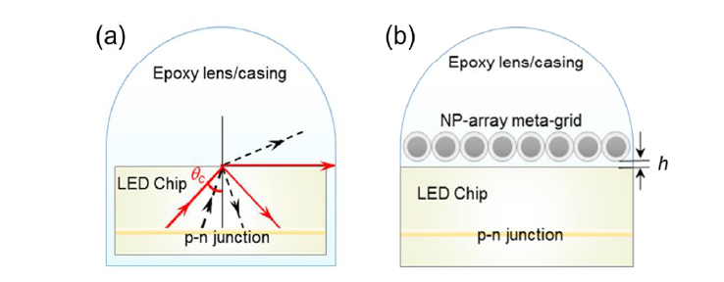In the lines 127 through 131, permittivity values have been assigned to different layers of the semiconductor LED with NP material. The different layers, as can be seen in Figure 6(b), are LED semiconductor, encapsulating material, NP layer, encapsulating material.

Figure 6: Schematic of semiconductor LED with and without NP layer

### Script modification for each run: Function script

In the following paragraphs, the function script as well as the modifications required has been explained. Figure 7 through 12 shows the entire function script in six different parts.

In this script, the formula for estimation of Transmittance and Reflectance has been implemented. Hence not much modification is required for each run.

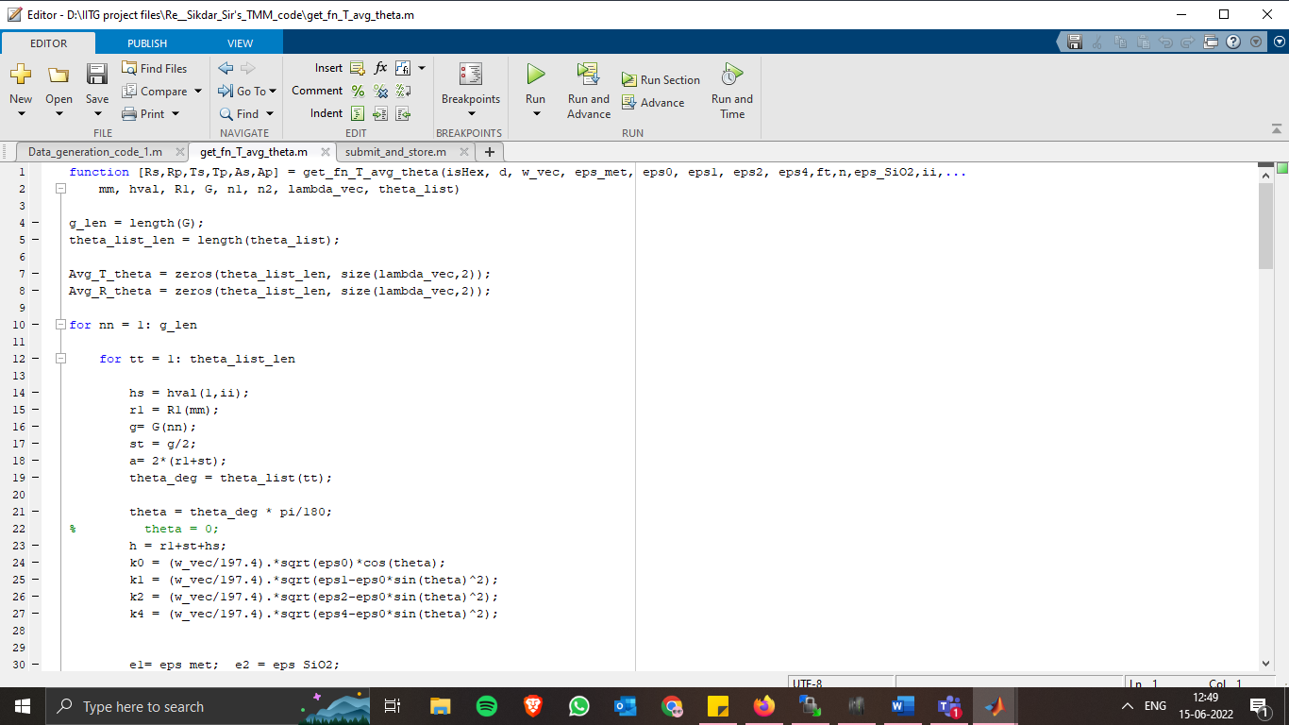

Figure 7: Function code (1/6)

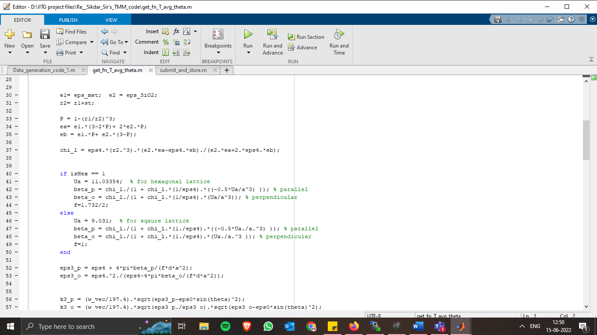

Figure 8: Function code (2/6)

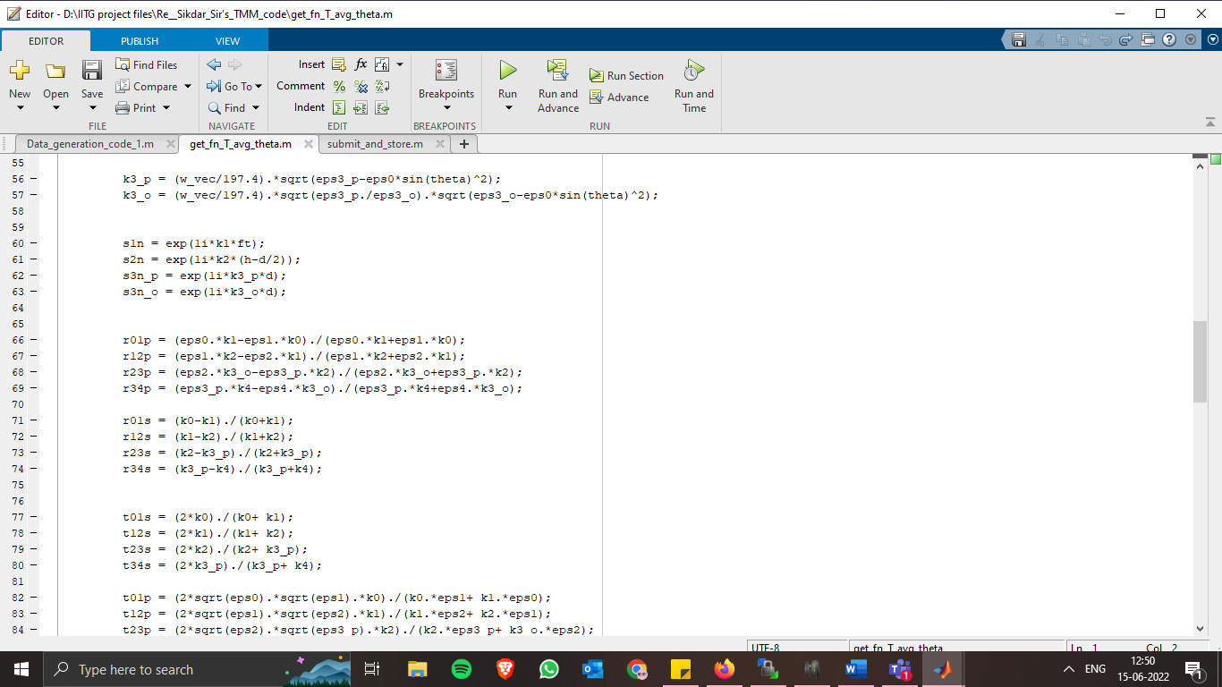

Figure 9: Function code (3/6)

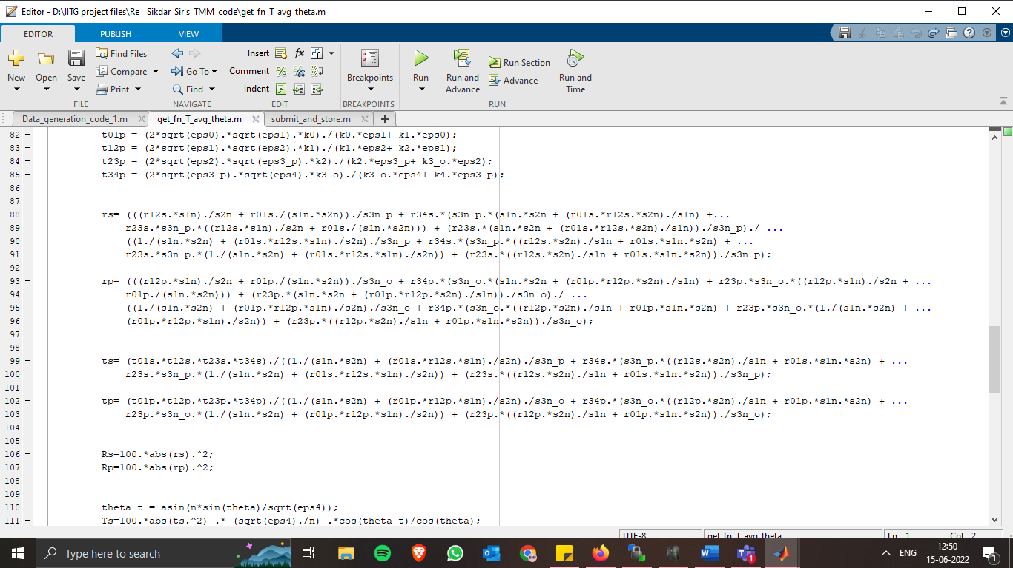

Figure 10: Function code (4/6)

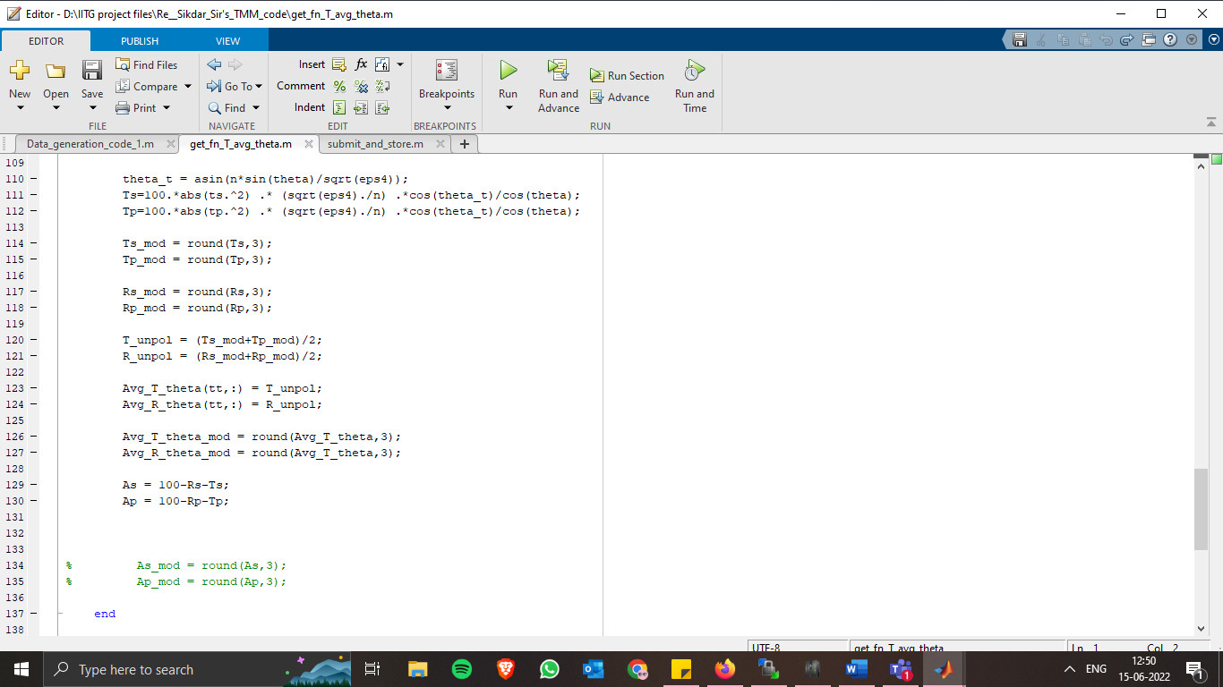

Figure 11: Function code (5/6)

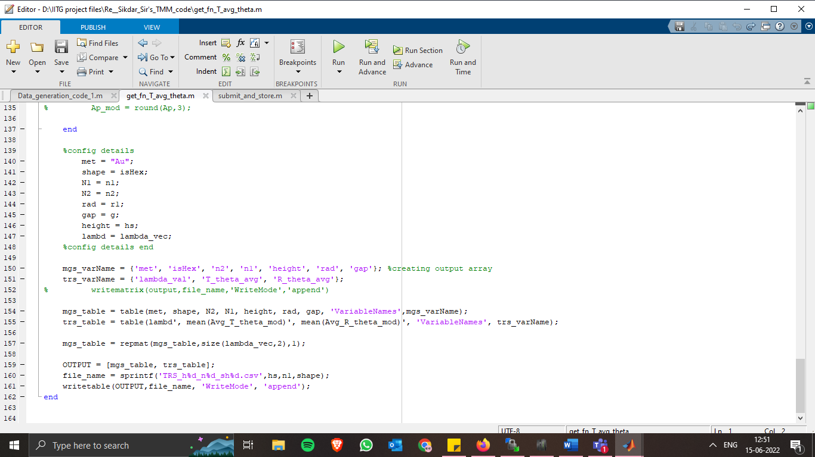

Figure 12: Function code (6/6)

Here in figure 12, a small modification, in line number 140, the value of ‘met’ must be changed for every run. The rest values will be automatically set. Lines 150 through 161 is to store the output file generated in separate files for each run. Line 160, in particular, ensures this by naming the files differently.

### Script modification for each run: Submit script

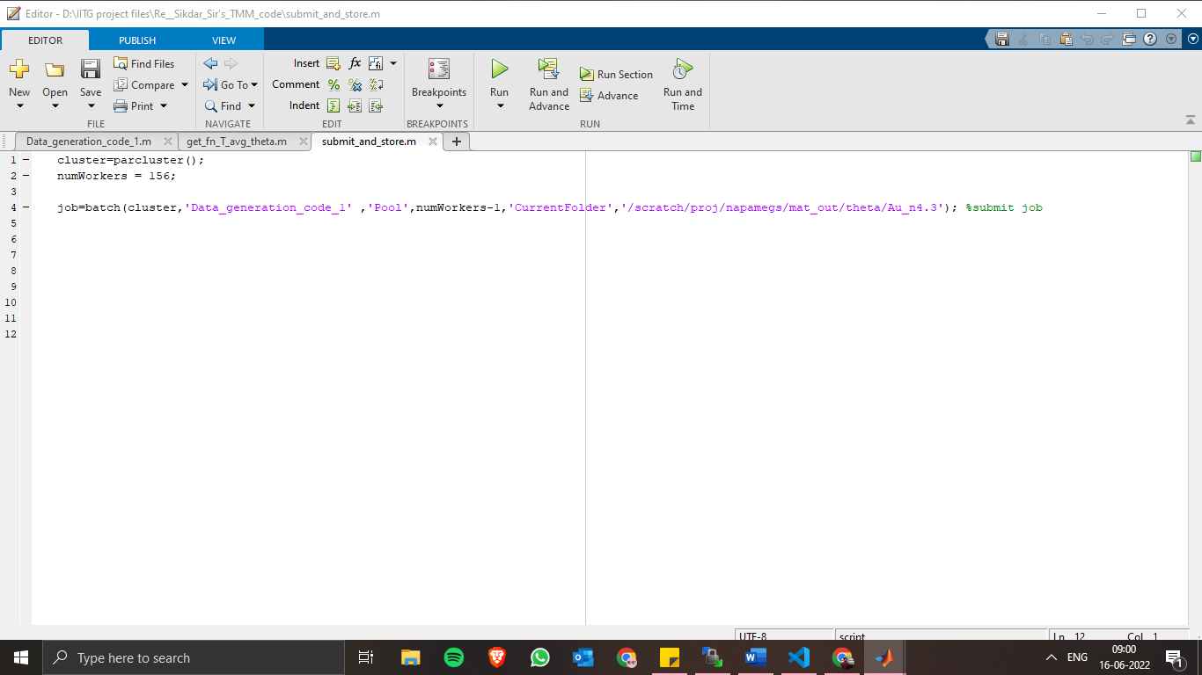

Figure 13: Submit script

Coming to the final script for data generation, the three lines viewed in figure 13 is used to submit the job to Param Ishan by specifying the number of cores required as well as the output folder. It is advisable to have the number of cores in multiple of 12.

# Managing the generated data

The data generated consumes a huge amount of memory. To put this in figures, each run produces exactly 1001 CSV files. For each material, for each value of semiconductor refractive index (n2), there will be 4004 (1001*4) such CSV files. One CSV files consumes around 3.3 GB of space. The same file takes only around 0.5 GB after compressing to .gz format.

So, it becomes necessary to compress the files after generation and transfer from Param Ishan memory to external storage device.

Followed below is the SLURM script to compress the generated data.

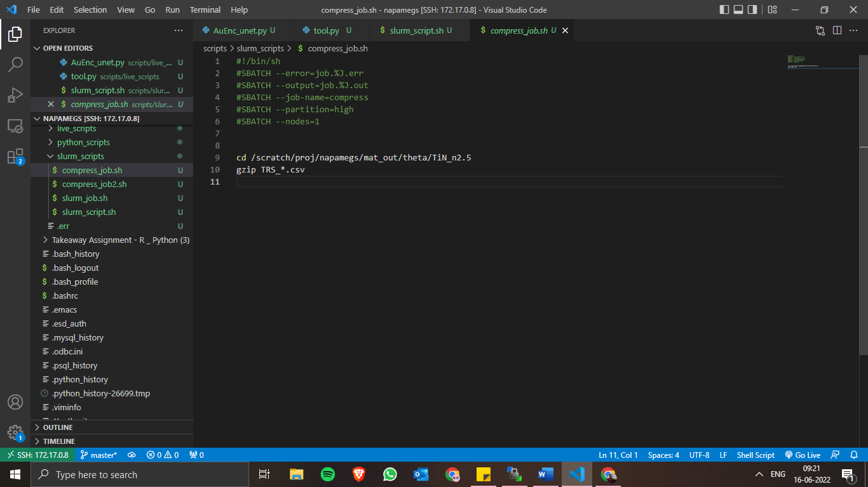

Figure 14: Compress script (SLURM)

It should be noted here that the job is run in high priority mode, and on single node.

The lines 2 and 3 are important to store the output and error files of the job. The “.%J” ensures that the files are named after the job number.

In line 9, the directory should be properly specified each time.

Line 10 performs the actual task of compressing the files. Here, we are compressing to ‘.gz’ format, hence the gzip command is used.

# Accessing Param Ishan

To submit jobs on Param Ishan, other than MATLAB, one has to access using SSH.

There are 3 best ways to do this. Firstly, one can use PowerShell or Command Prompt to initiate a SSH connection. Secondly, one can make a desktop shortcut which will connect to Param Ishan via SSH on double-clicking, and lastly one can ‘Remote-SSH’ extension of VS Code IDE to use all the GUI features of VS Code in Param Ishan. The third method is most recommended for Python and other scripting, as it is very easy to use.

To connect using PowerShell or Command Prompt, one simply needs to type the command

> ssh -X napamegs@param-ishan.iitg.ac.in

To make a double-clickable desktop icon, follow the below steps.

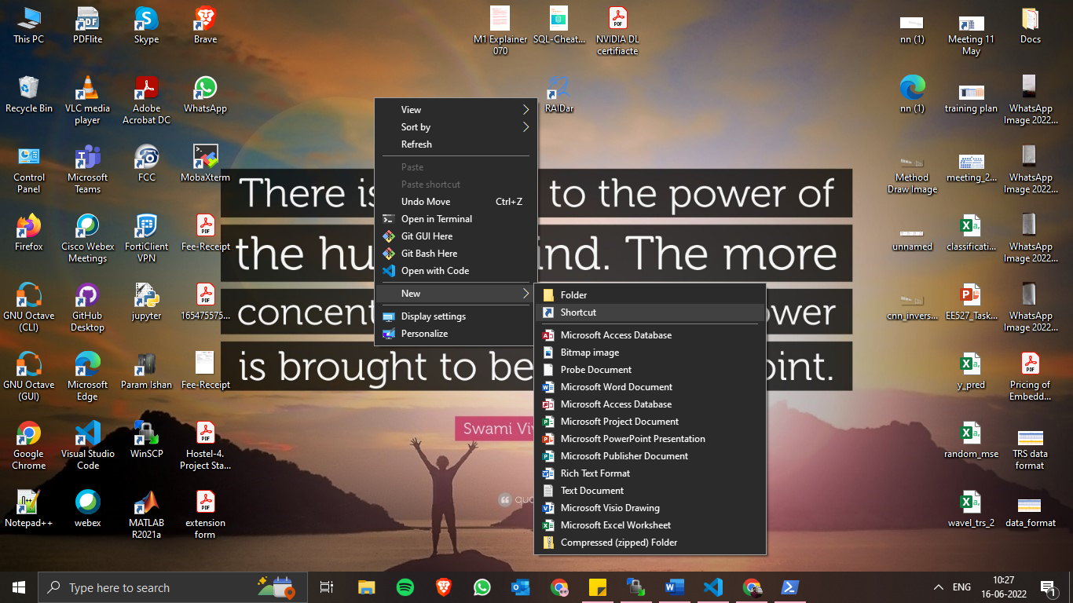Right-click on Desktop. Then click on ‘New’, followed by ‘Shortcut’.

Figure 15: Create Icon (1)

Figure 16: Create Icon(2)

In the “Create Shortcut” menu box, enter the following line as location.

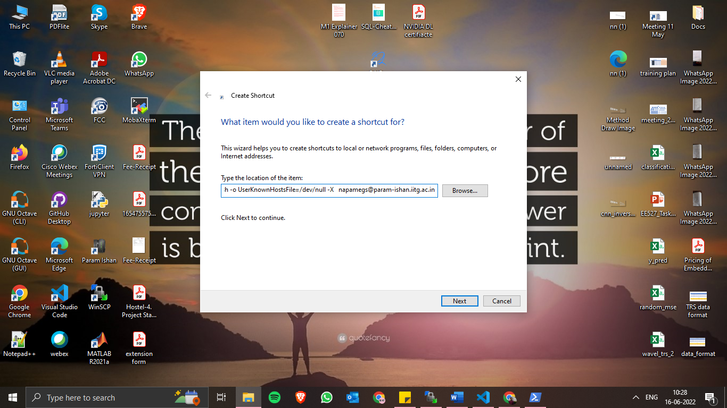“*C:\Windows\System32\WindowsPowerShell\v1.0\powershell.exe -command ssh -o UserKnownHostsFile=/dev/null -X napamegs@param-ishan.iitg.ac.in*”

Figure 17: Create Icon (3)

Click on next to continue.

In the next page, enter the desired name of the icon, say “Param Ishan”.

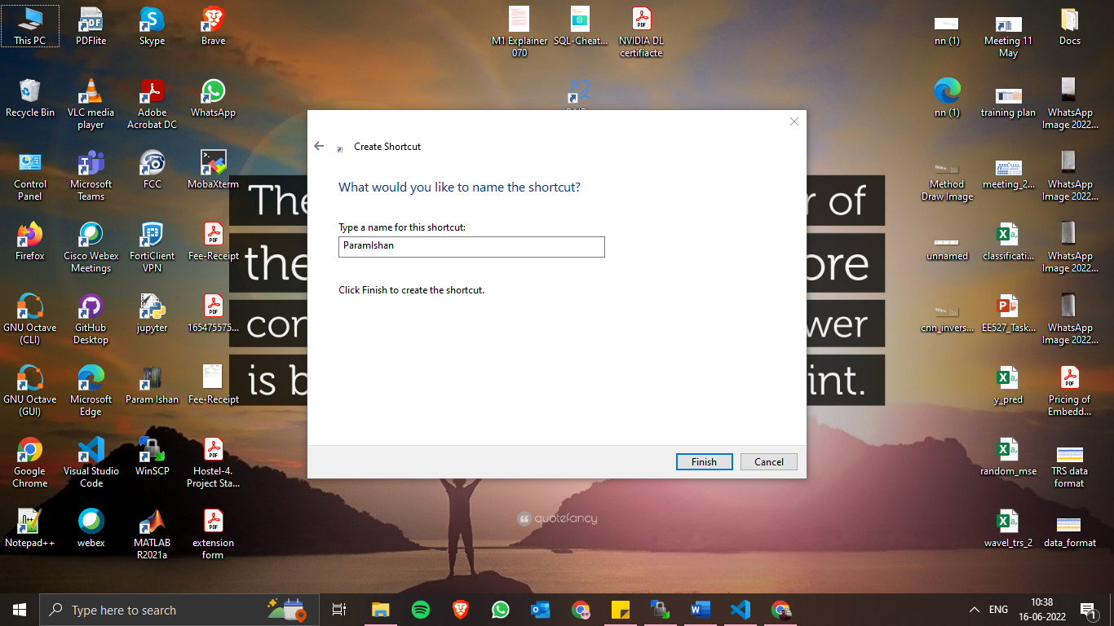

Figure 18:Create Icon(4)

Click on finish to finally create the desktop icon.

Figure 19: Created Icon

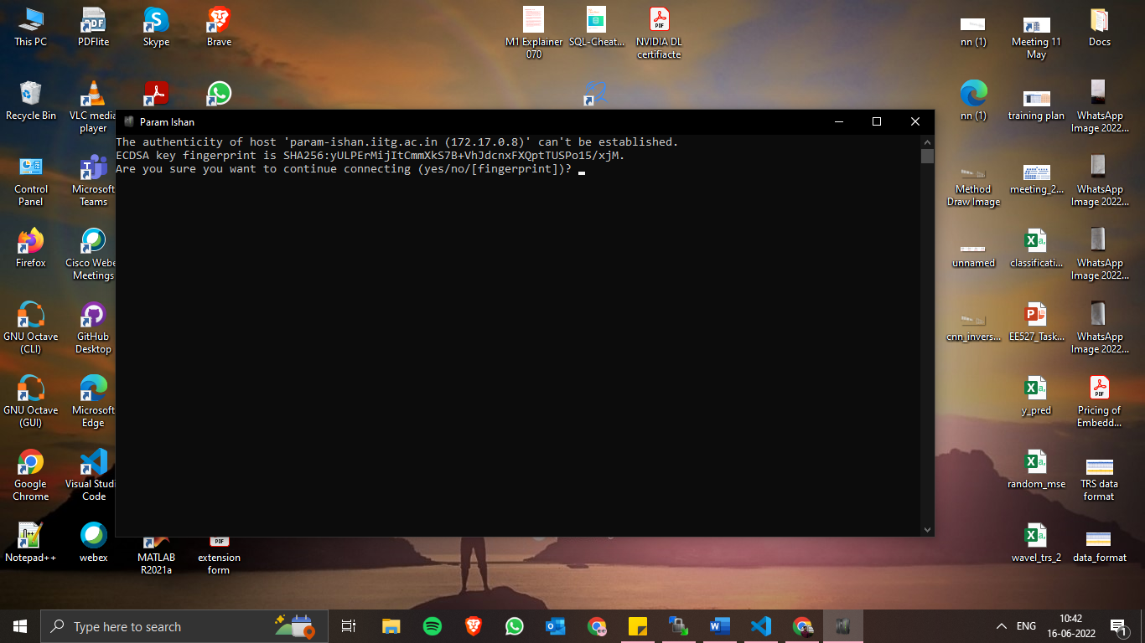On double-clicking each time, the following page will appear.

Figure 20: Connect using Icon (1)

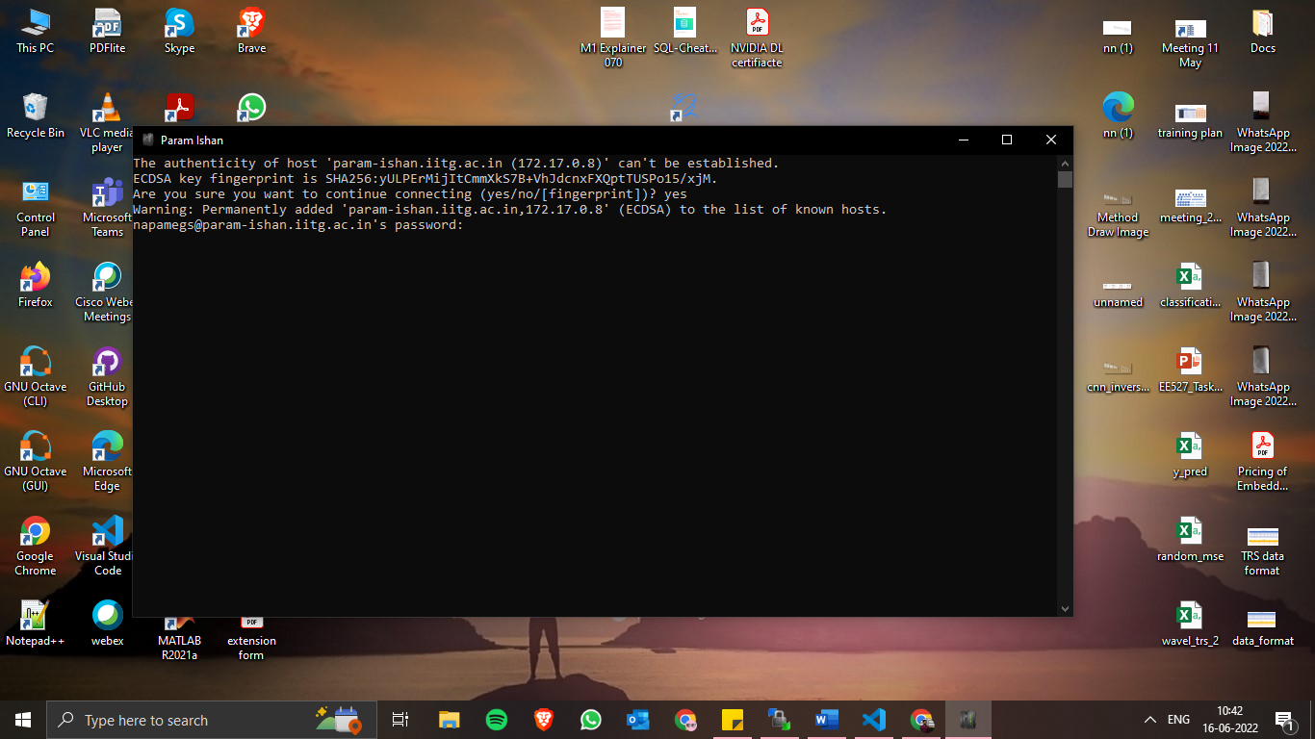It is necessary to type ‘yes’ and accept the hashing key to continue. On clicking yes, login password will be asked for the “napamegs” account.

Figure 21: Connect using Icon (2)

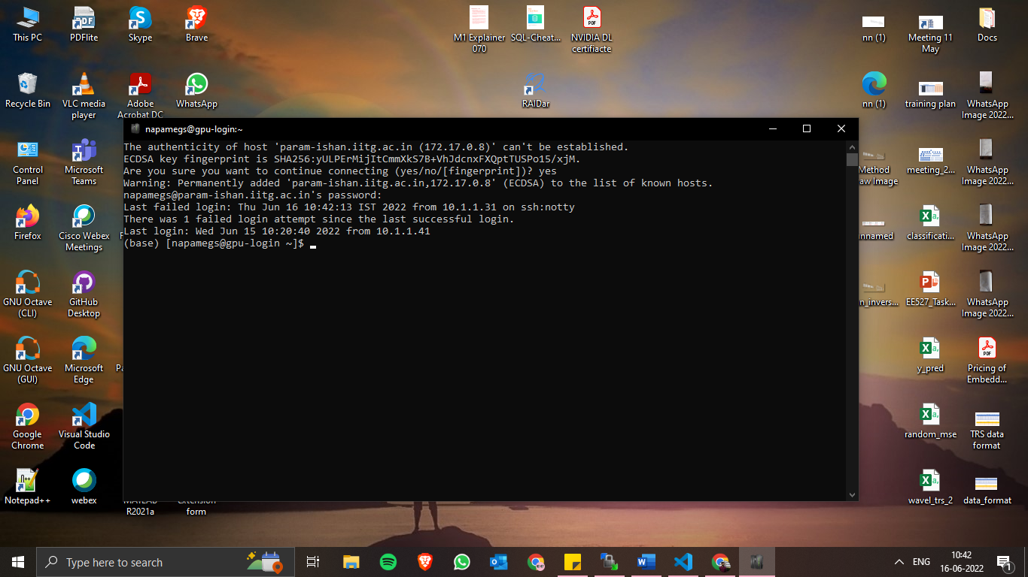Enter the password to finally login to the account. Either of “mic-login”, “gpu-login”, or cpu-login” will be assigned in round robin fashion.

Figure 22: Connect using Icon (3)

In order to change from one login, say cpu-login1, to another, say gpu-login, simply type

> ssh gpu-login

Follwed by the password when prompted. For using the Param Ishan GPU, it is important to submit a job from GPU-login. So, this tip may come handy at that time.

Kindly note that the process of logging in after double-clicking the desktop icon and after entering the SSH command on PowerShell is exactly same.

## Using VS Code for remote access

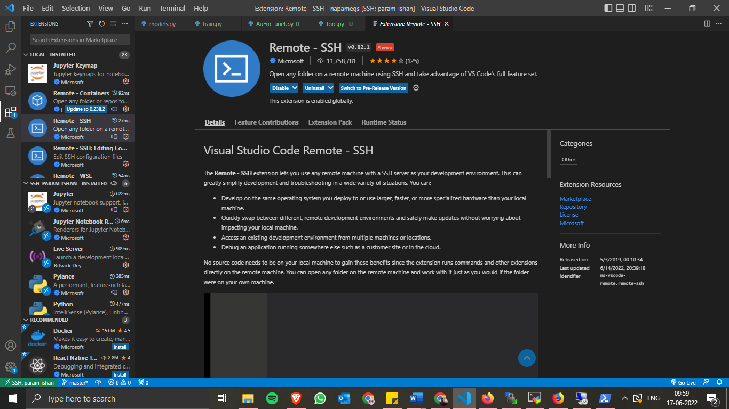After installing VS Code on local system, go to the extensions tab on the left and search for “Remote SSH” and install it.

Figure 23: Connect VS Code (1)

After successful installation, click on the green button at the bottom left corner of the screen.

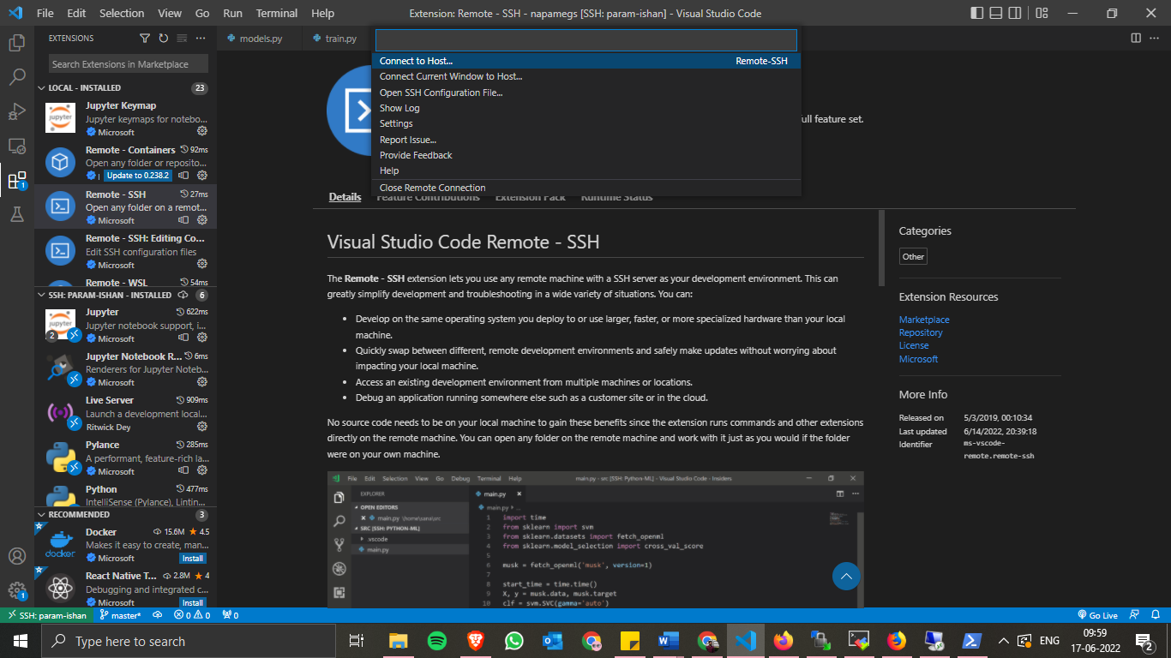Click next on the “Connect to host” option.

Figure 24: Connect using VS Code (2)

On the screen that follows, enter the following command:

ssh -X napamegs@param-ishan.iitg.ac.in

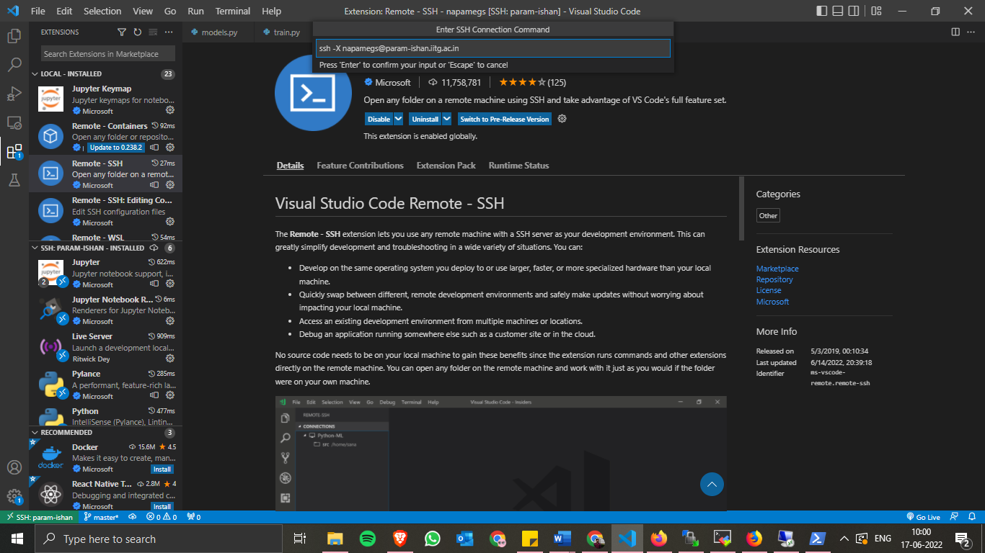

Figure 25: Connect using VS Code (3)

This will successfully add a host. Again, click on the green box on the bottom left corner of the screen and accept the fingerprint key and enter the password to connect to remote window.

It is to be noted here that the fingerprint key will change after specific time and the known hosts list should be cleared in order to allow new connections.

To do that, click once again on the green button on the bottom left corner of the screen and subsequently click on “open SSH configuration file”. There enter the command below:

GlobalKnownHostsFile /dev/null

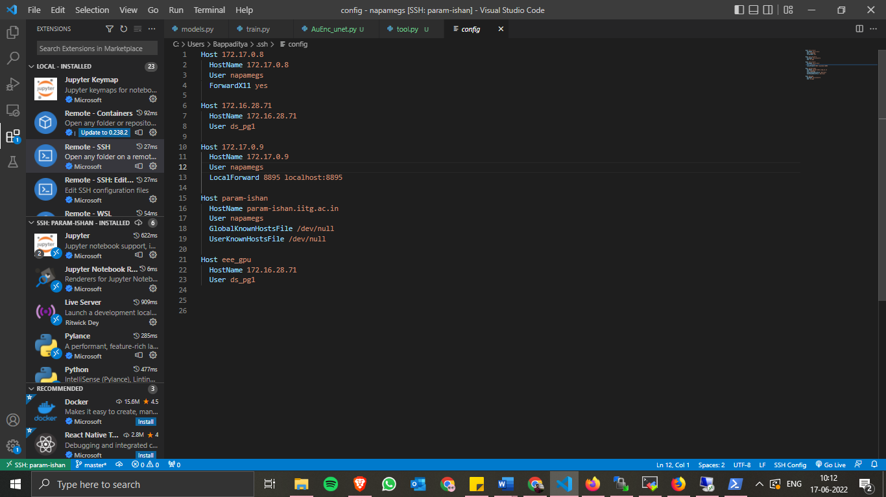LocalKnownHostsFile /dev/null

Figure 26: SSH configuration

One may also enter a name (like param-ishan here) for easy identification when there are multiple hosts added.